1. **图的遍历**

**Question**

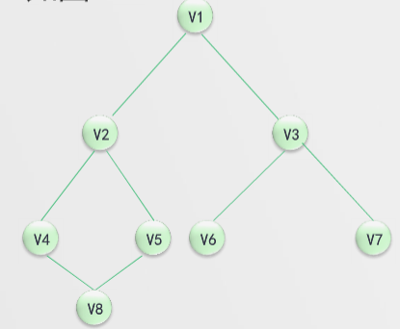

**Answer:**

